**ASSIGNMENT # 02**

FINDING SMALLEST, SECOND SMALLEST AND

LARGEST ELEMENTS OF AN ARRAY



**Spring 2023**

**Computer Programming Theory**

Submitted by: **JAMAL KHAN**

Registration No. : **22PWCSE2203**

Class Section: **B**

“On my honor, as student of University of Engineering and Technology, I have neither given nor received unauthorized assistance on this academic work.”

Student Signature: ______________

Submitted to:

**Dr. M Athar Sethi**

May 30, 2023

Department of Computer Systems Engineering

University of Engineering and Technology, Peshawar

Finding the largest element of an integer array.

* ***Source code:***

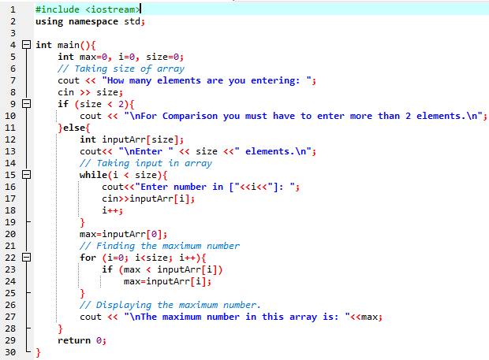

* ***Output*:**

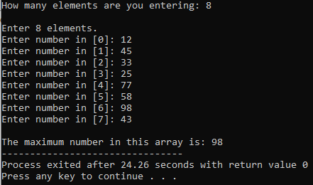

Finding the second smallest elements in a given array of integers.

* ***Source code:***

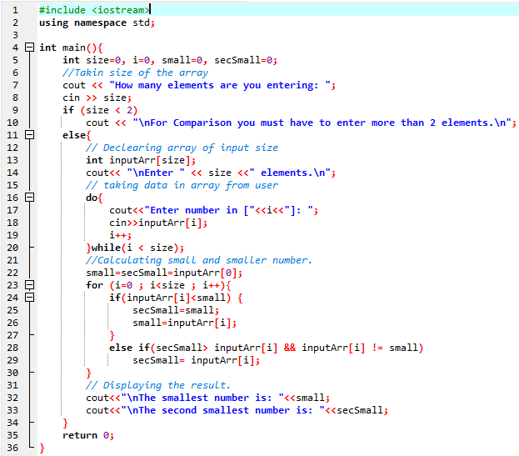

* ***Output*:**

